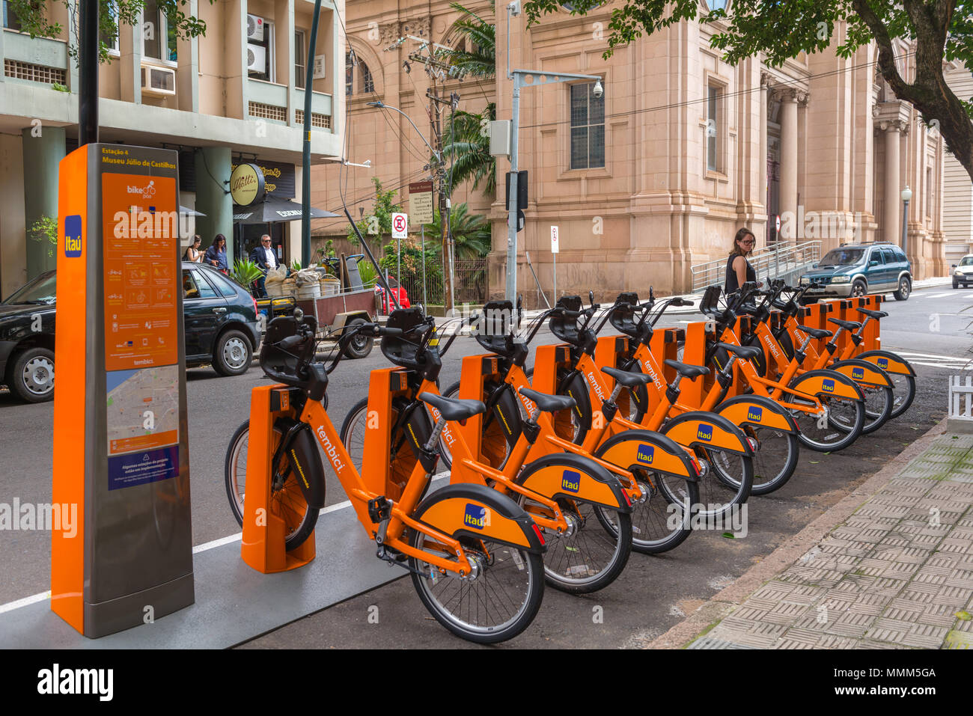

Abstract:

Bike sharing systems are a means of renting bicycles where the process of obtaining membership , rental , and bike return is automated via a network throughout the city.

Bike rental

Prediction

Insights of data

INSIGHTS OF DATA

1. **ABOUT DATASET:**

* **Instant** : Its just referring to the index.
* **dteday** : It represents the date of bike rented.
* **season** : It defines the type of season (1:springer, 2:summer, 3:fall, 4:winter).
* **yr** : It defines which year (0: 2011, 1:2012).
* **mnth** : It represents the month from jan to dec ( 1 to 12).
* **hr** : It represents the hour from 0 to 23. (0 to 23).
* **holiday** : It defines weather day is holiday or not.
* **weekday** : It defines the day of the week.
* **workingday** : if day is neither weekend nor holiday is 1, otherwise is 0.
* **weathersit** :
  + - * 1: Clear, Few clouds, Partly cloudy, Partly cloudy.
      * 2: Mist + Cloudy, Mist + Broken clouds, Mist + Few clouds, Mist.
      * 3: Light Snow, Light Rain + Thunderstorm + Scattered clouds, Light Rain + Scattered clouds.
      * 4: Heavy Rain + Ice Pallets + Thunderstorm + Mist, Snow + Fog.
* **temp** : Degree of hotness or coldness measured on a definite scale.Normalized temperature in Celsius. The

values are divided to 41 (max).

* **atemp** : The heat index, also known as the apparent temperature, is what the temperature feels like to the

human body when relative humidity is combined with the air temperature. This has Important

considerations for the human body's comfort. Normalized feeling temperature in Celsius.The Values are

divided to 50 (max).

* **hum** : Normalized humidity-Humidity is the amount of water vapor in the air. If there is a lot of water vapor

in the air, the humidity will be high. The higher the humidity, the wetter it feels outside. On the

weather reports, humidity is usually explained as relative humidity.. The values are divided to 100

(max).

* **windspeed** : Normalized wind speed.-the rate at which air is moving in a particular area. The values are divided to

67 (max).

* **casual** : Count of casual users.
* **registered** : Count of registered users.
* **cnt** : Count of total rental bikes including both casual and registered.

1. **UNIVARIATE ANALYSIS :**

* **Season** - Every season has equal proporttion of demand with little difference.
* **Year** - The data is distributed 50/50 i.e 2011 and 2012 respectively.
* **Month** - The beginning and ending months has high demand than other months.
* **Hour** - We can see the peakness in the following hours 0-1,7-8,15,22-23.
* **Holiday** - The demand is more on working days i.e 97%.
* **Weekday** - Every day has equal demand.
* **Workingday** - Working day has more demand than holidays.
* **Weathersit** - The clear day(1) has more demand than other days.
* **Temperature** - The high frequency is b/w 0.20 to 0.79.
* **atemp** - The actual feeling of temperature has linear movement from 0.20 -0.62.
* **Humidity** - High frequency is b/w 0.42-0.82
* **Windspeed** - The peakness is b/w 0.10 to 0.17.
* **Casual** - Count of casual customers are more at o.
* **Registered** - Count of 4,3,5,6 are more when compared to others.
* **Count** - The sum of casual and registered is more at the count 5.

1. **BIVARIATE ANALYSIS :**

* **Season** - There is very less demand in the 1st season ie winter.
* **Year** - The demand for renting bikes is incresed in the year 2012 when compared to the previous year.
* **Month** - The demand is more b/w 5th month to 10th month
* **Hour** - There is very less demand the sleeping hours till 6 but we can see the peakness at 8th hour and then it

maintained same demand from 11 to 17 and we can again see the peakness at 18 and 19.

* **Holiday** - There is a high demand for rental bikes in the working days.
* **weekday** - There is a less demand in the weekends.
* **Workingday** - There is high demand in the workingdays.
* **Weathersit** - When the weather is becoming worse we can see that there is gradual decrease in the demand.
* **Temperature** - There is a positive linear relationship b/w temperature and the demand but when there is max

temperature the demand again falls.

* **atemp** - Same as temperature.
* **Humidity** - The demand is peaked when there is less humidity and we can see there is a gradual decrease when

the humidity is increasing.

* **Wind speed** - No specific pattern but we can see that there is constant demand till 0.6 and after the we can see

sudden ups and downs.

* **Casual** - Casual users are very less.
* **Registered** - Registered people are the key players in renting bikes.